INTRODUCTION TO DATA SCIENCE
PYTHON LAB
NAME: ABDULLAH AYUB
ROLL: BSDSF24M029

Provided Data:

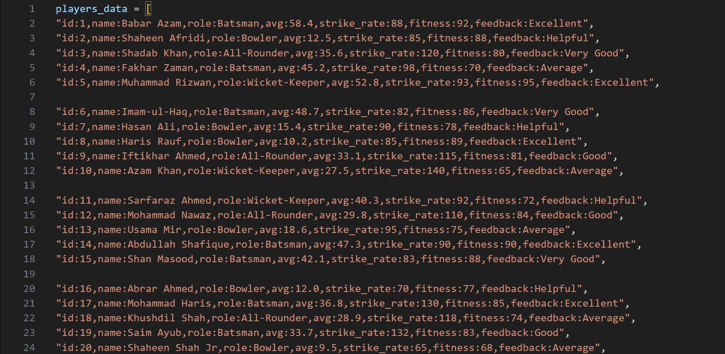
Task1: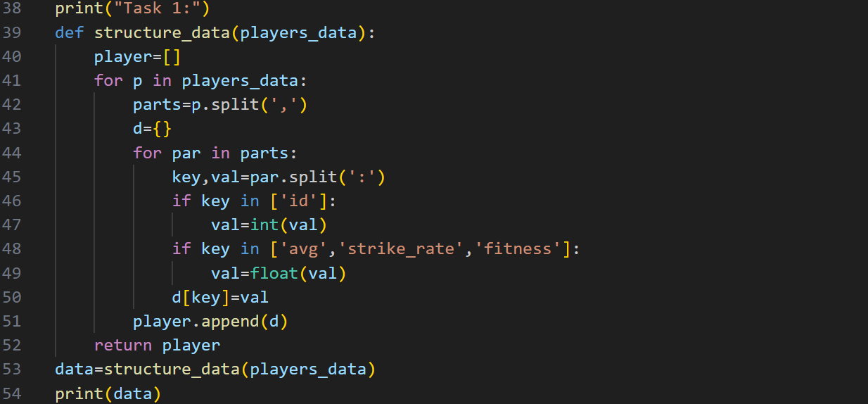
Output:
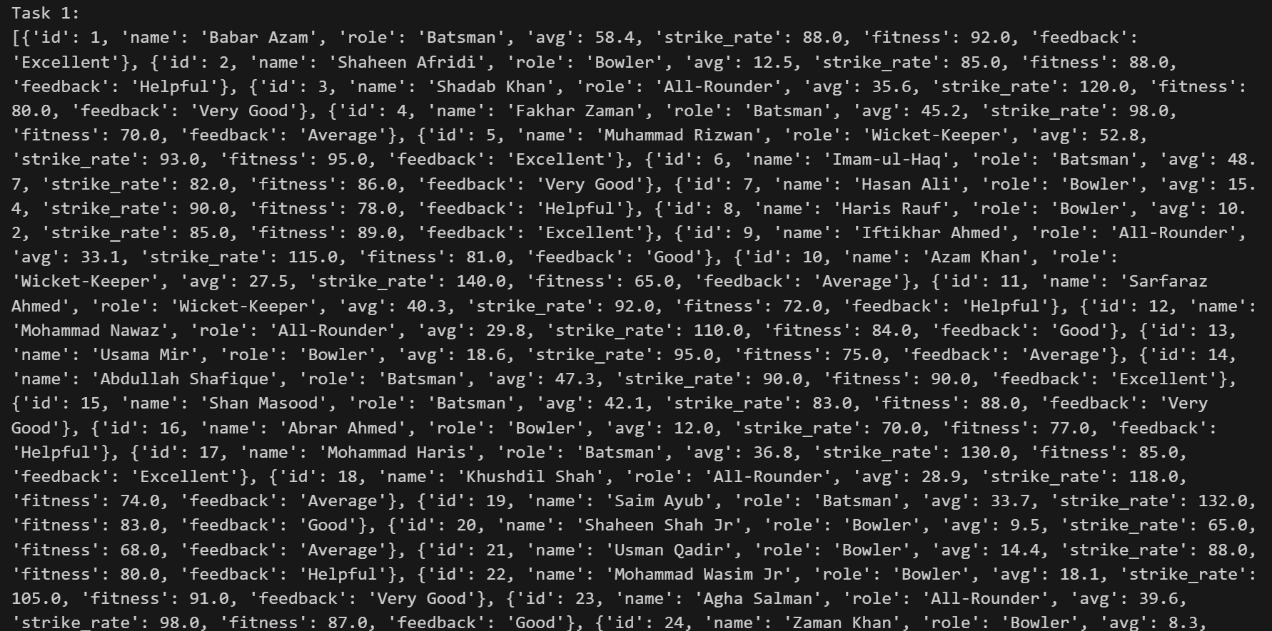
Explanation:
My first and most critical step was data preparation. I took the raw text strings, which were difficult to work with, and converted them into a list of Python dictionaries. This involved iterating through each record, splitting the data first by the comma and then by the colon, and assigning the results to key value pairs. Crucially, I performed type casting on the numerical fields (avg, strike_rate, fitness) to ensure they were stored as floating-point numbers, allowing for correct mathematical operations later on.
Task2:
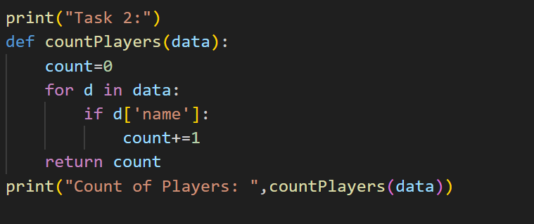

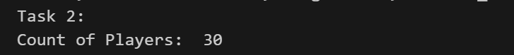

This task served as a quick data validation check. By simply iterating through the newly structured player data list and incrementing a counter, I was able to get an accurate total count of all players in the dataset. This confirmed that no records were lost or corrupted during the initial data structuring phase.
Task3: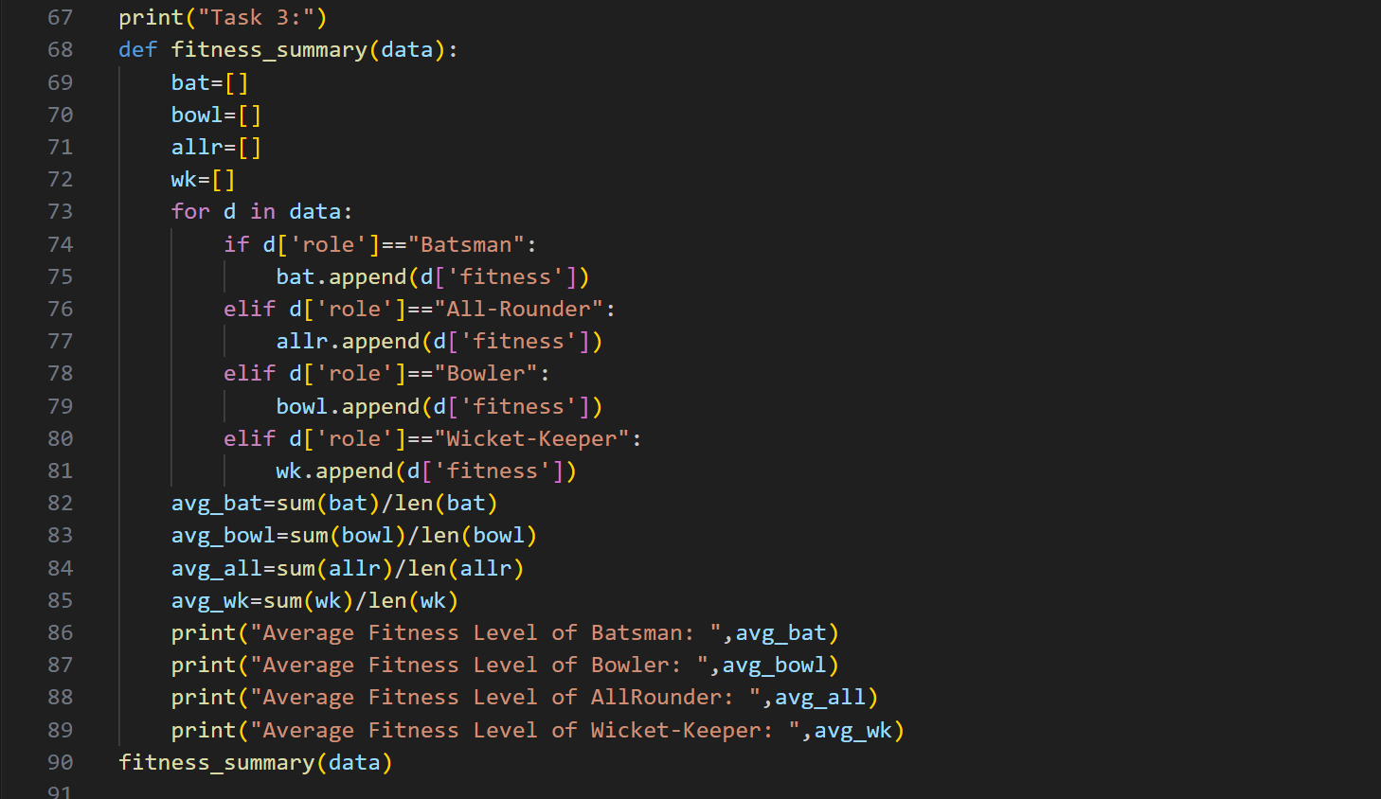
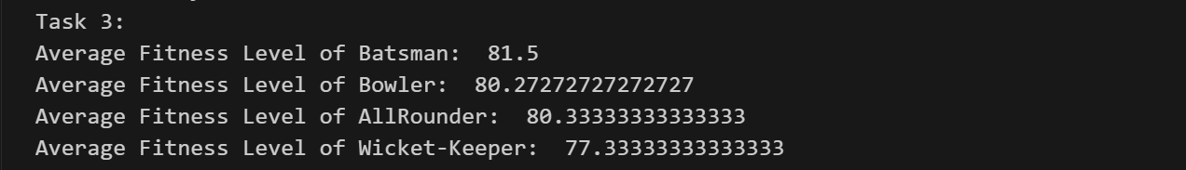

To assess the physical conditioning of different components of the team, I calculated the average fitness score for each distinct role (Batsman, Bowler, etc.). I achieved this by filtering and accumulating the fitness scores into separate lists based on the player's role, and then finding the mean (sum divided by count) for each group. This benchmark is vital for tailored training programs.
Task4:
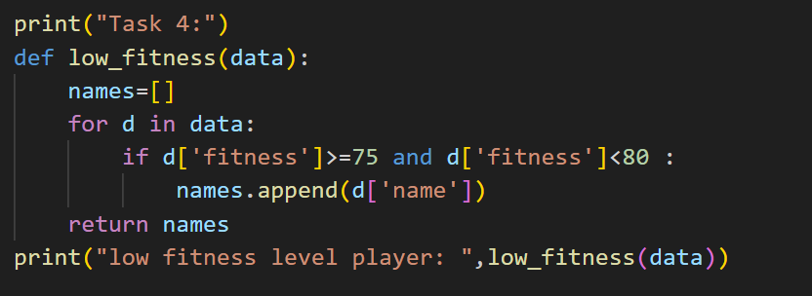

Identifying high-risk athletes is essential for injury prevention. I set a threshold and used a simple conditional check to flag any player whose fitness score fell below 75%. The names of these players were collected into a list, allowing selectors to easily identify those who need immediate attention from the medical and training staff.
Task5:

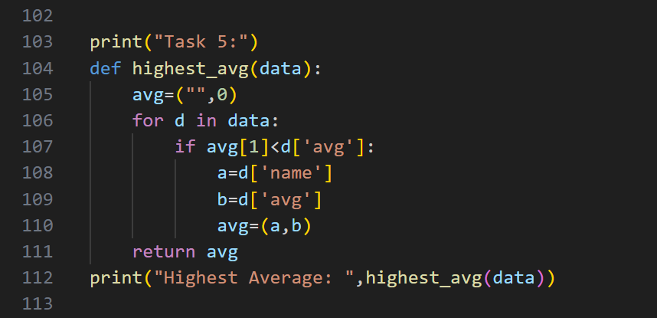

I iterated through all players, maintaining a variable that tracked the currently highest known batting average and the corresponding player's name. This comparison logic guaranteed that the final output accurately represented the top-performing player in terms of batting consistency across the entire squad.
Task6:
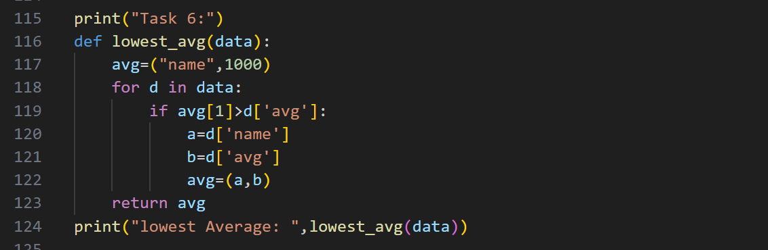

Similar to finding the maximum, I initialized a variable with an unrealistically high average and used comparison logic to continuously update it whenever a lower batting average was found. This highlights the player who is currently struggling the most for runs and consistency.
Task7:
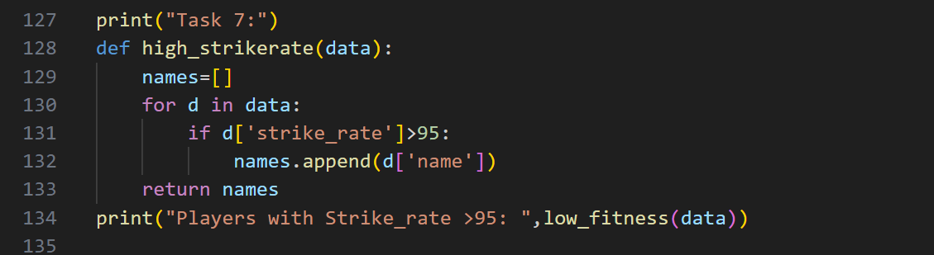

This task focused on identifying power and aggression. I used a specific conditional filter to collect the names of all players who possess a strike rate greater than 95. These players are valuable assets for accelerating the scoring rate during an inning.
Task8:
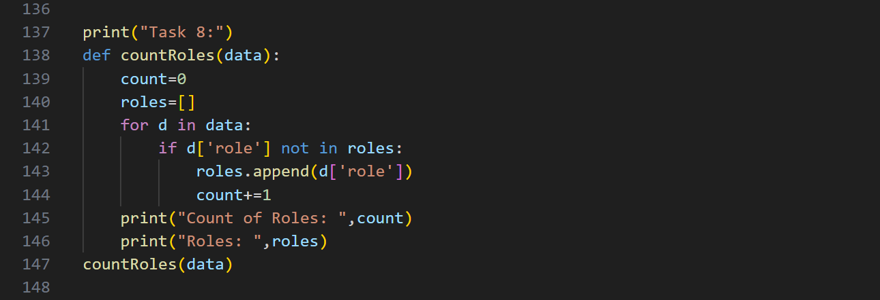

I checked the diversity of the squad by counting how many distinct roles were present in the dataset. This was done by iterating through the data and tracking which roles had already been encountered, ensuring that the team structure includes all necessary specialists, such as Batsmen, Bowlers, Wicket-Keepers, and All-Rounders.

Task9: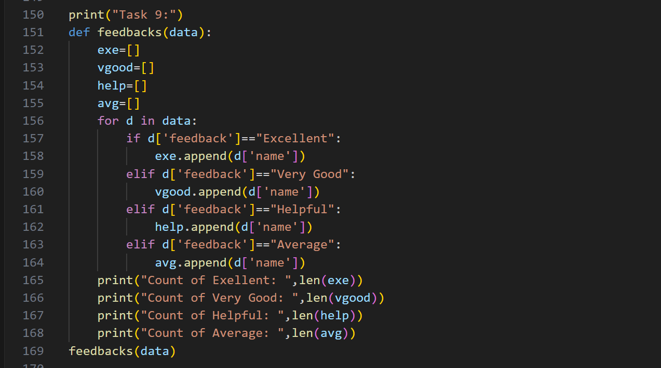

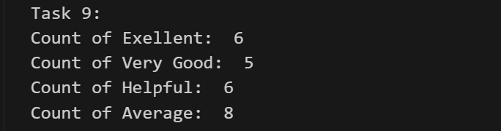

I quantified the subjective performance assessments by counting the frequency of each feedback category ("Excellent," "Helpful," "Average"). By grouping players based on their qualitative rating, I was able to assess the overall perceived contribution of the squad.
Task10:
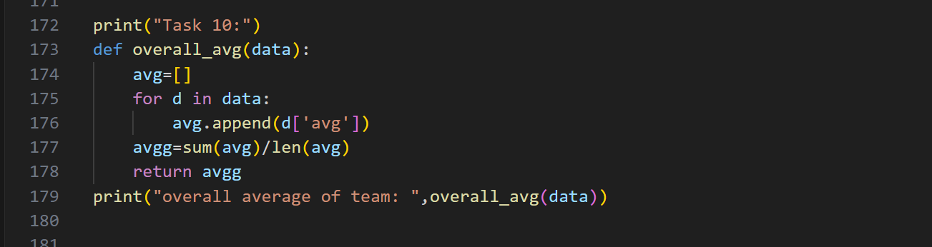

To get a collective measure of the team’s batting quality, I collected all individual batting averages into a single list. The overall team average was then calculated by summing these scores and dividing by the total number of players. This metric serves as a baseline for the team's run-scoring capability.

Task11:
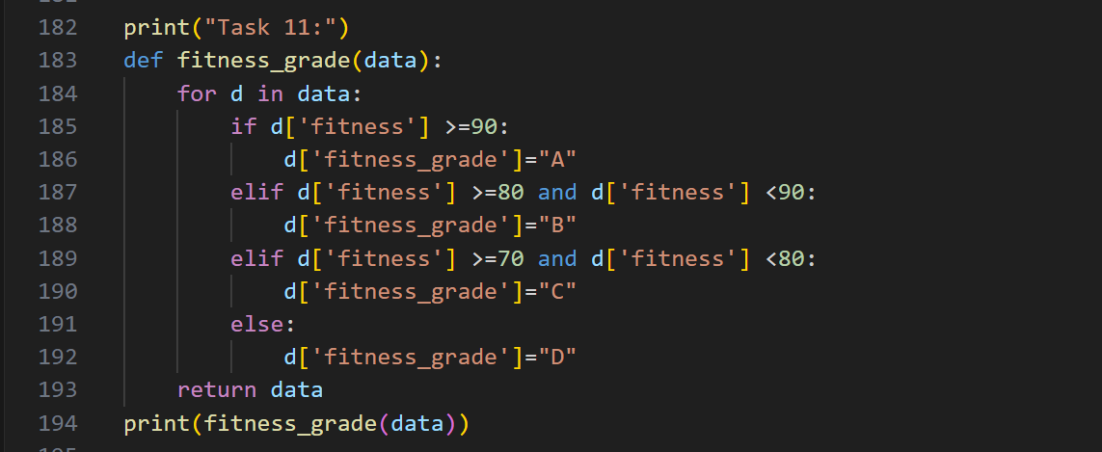

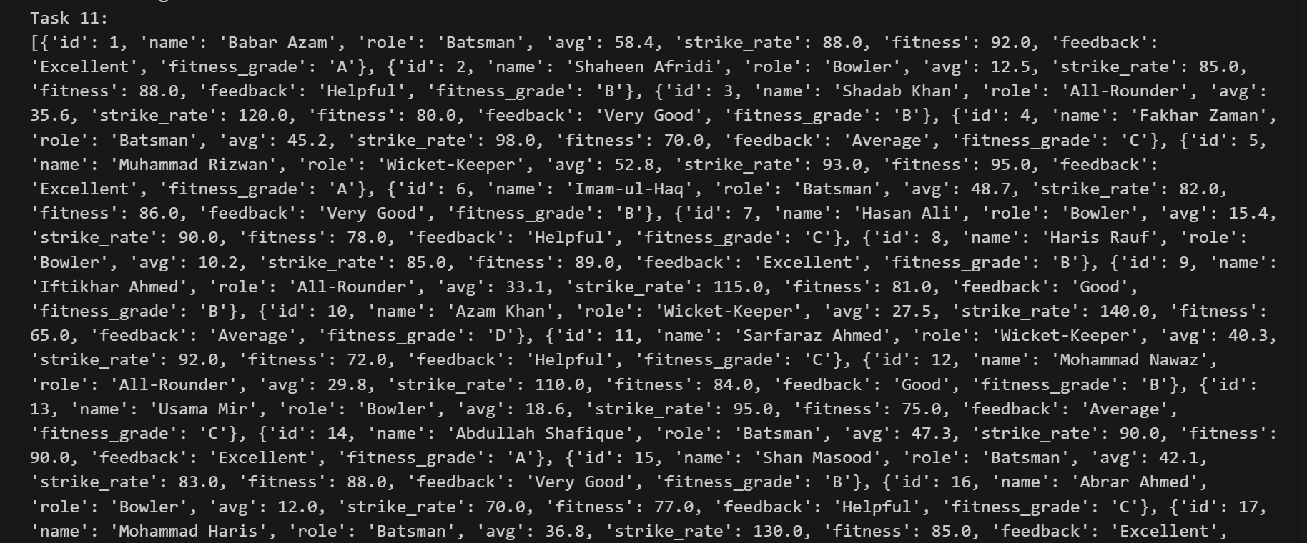

To simplify the interpretation of fitness scores, I implemented a system of conditional grading. Using a series of if/elif statements, I assigned a new categorical field, fitness_grade (A, B, C, or D), to each player based on defined numerical thresholds (e.g., 90+ is A), making fitness status easier to report.
Task12:

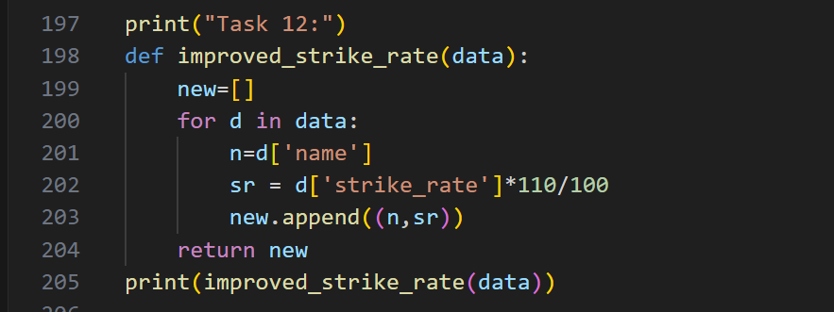

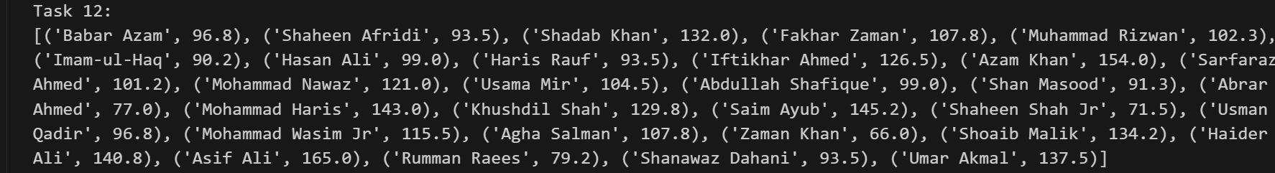

For strategic planning, I executed a simple data projection. I calculated a hypothetical new strike rate for every player by applying a 10% increase to their current score. This gives selectors insight into the team's potential ceiling if a training goal is successfully met.
Task13:

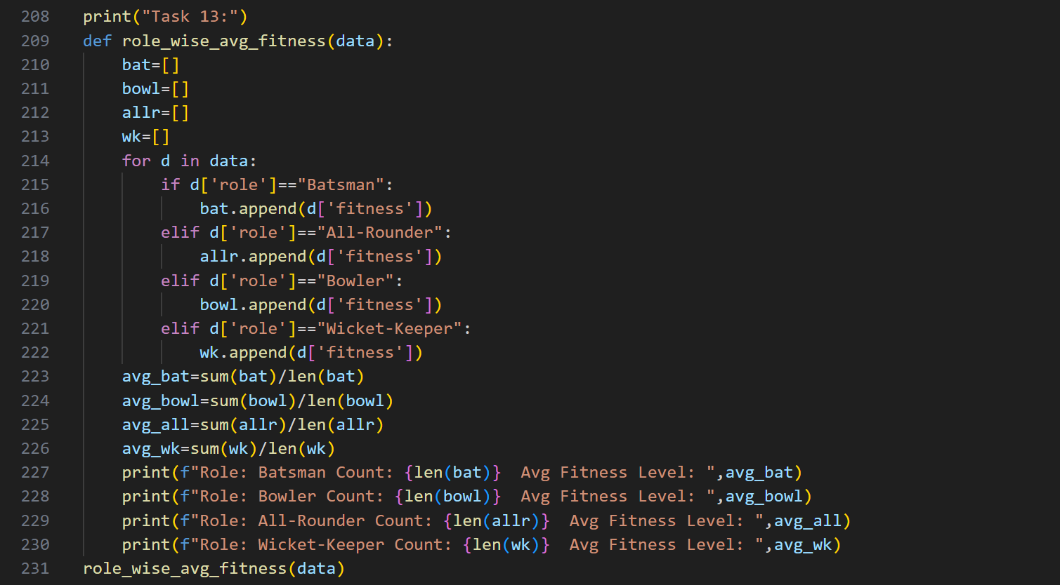

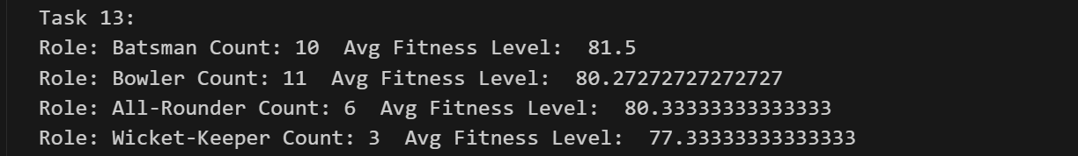

This report consolidates two key pieces of information for strategic team construction. For every role, I calculated and displayed both the number of players currently occupying that role (the roster size) and their average fitness level. This view helps selectors quickly judge if a specific area of the team is strong, weak, or adequately staffed.

Task14: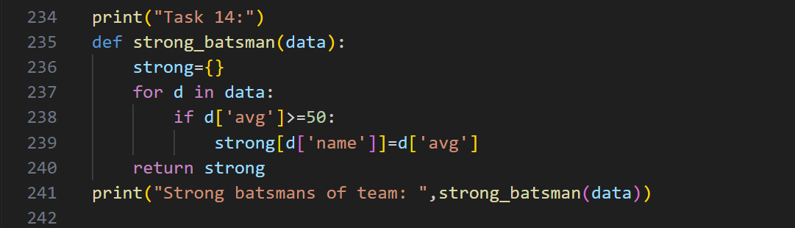

I specifically isolated players whose role is 'Batsman' and applied a filter to only include those whose batting average is 50 or higher. The result is a concise list of the team's most reliable and consistent run-scorers, forming the backbone of the batting unit.
Task15:

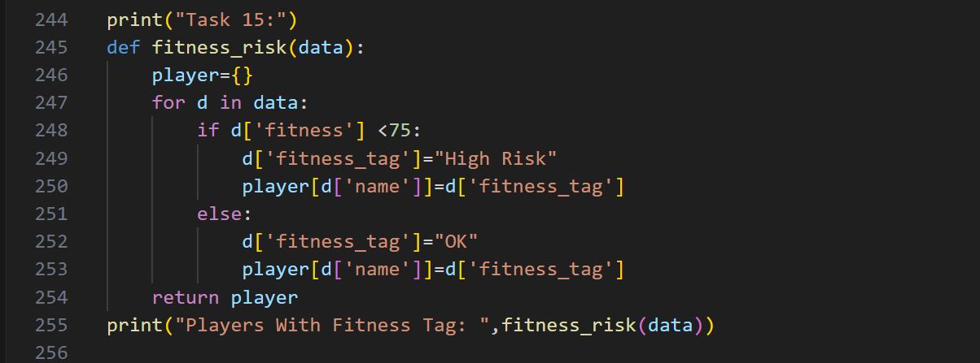

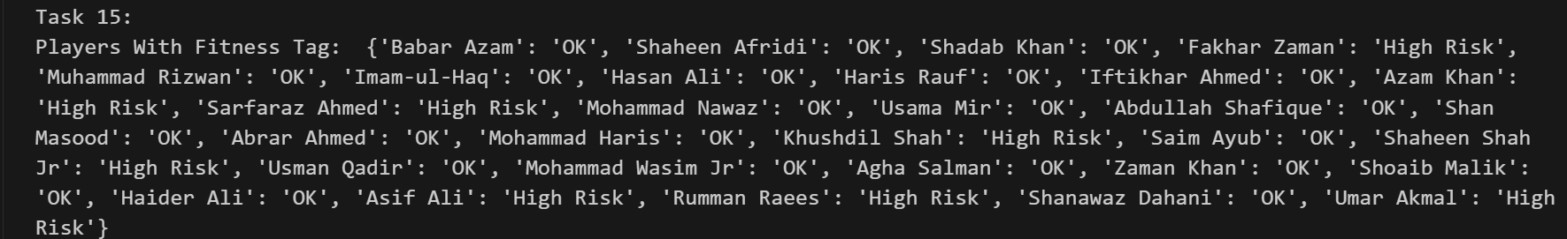
I applied a clear, binary tag for immediate risk assessment. Players with a fitness score below 75 were automatically tagged as "High Risk," while all others were marked as "OK." This adds a high-priority flag directly to the player record for selection meetings.

Task16: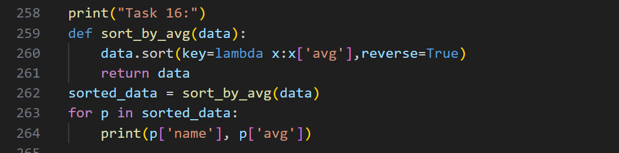

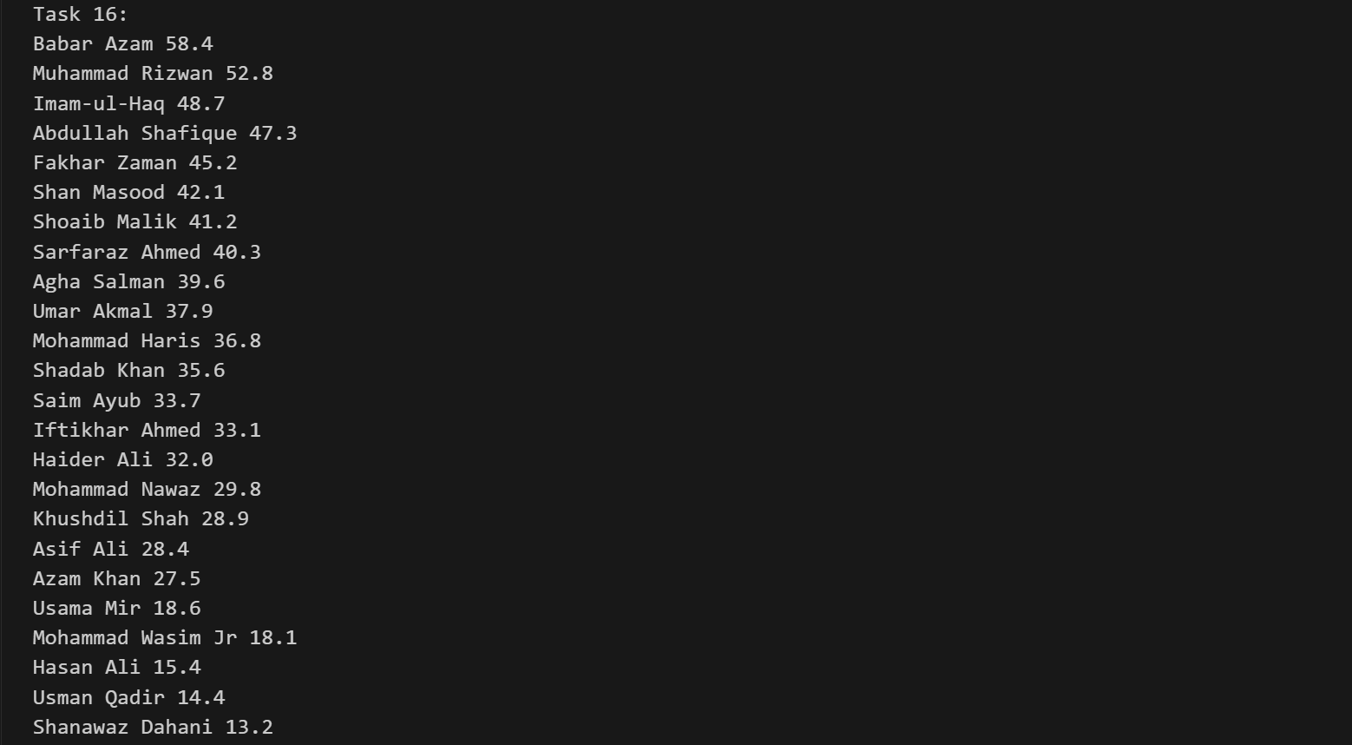

I leveraged Python’s built-in sort() function along with a lambda function to efficiently rearrange the entire list of player dictionaries. The data was sorted in descending order based on the avg key, providing an immediate, ranked view of performance.
Task17:

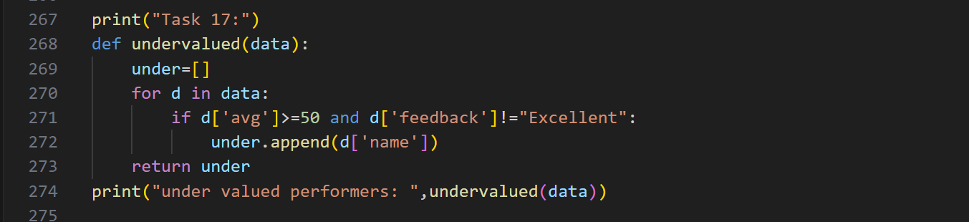

This task used a compound filter to find potential strategic gems: players who have an average of 50 or higher but whose feedback is not "Excellent." This combination suggests players who are consistently performing well but might be flying under the radar in qualitative reviews.
Task18:

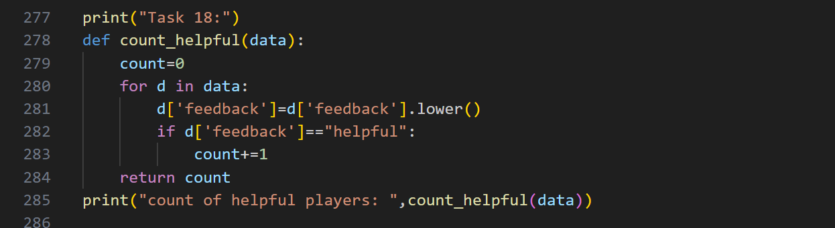

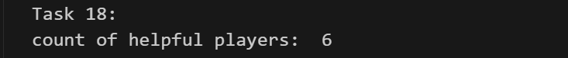

To ensure accurate counting regardless of inconsistent capitalization in the data, I first used the string method .lower() to convert all feedback to lowercase. I then reliably counted how many players received the normalized feedback of "helpful".
Task19:

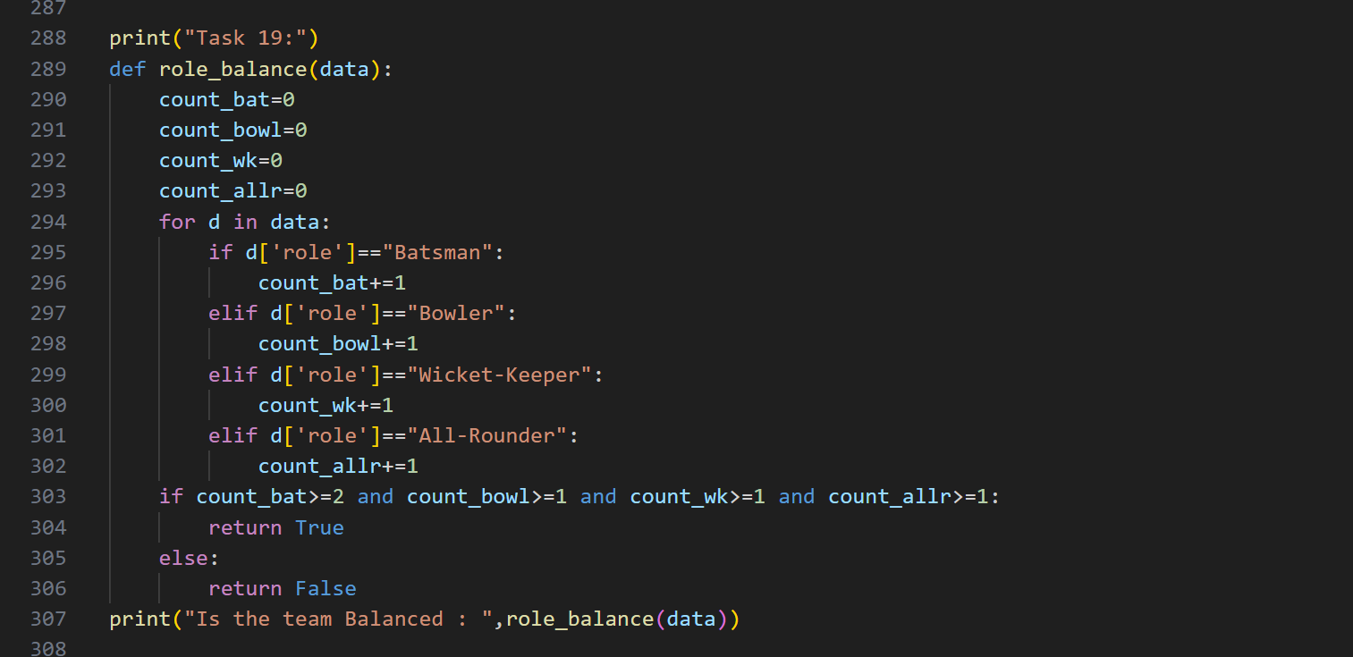

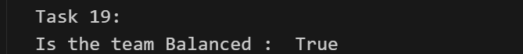

To ensure a balanced team composition, I implemented a formal check against required minimums (e.g., at least 2 Batsmen, 1 Bowler). I counted the players in each role and then used a compound logical check (and statements) to return a simple True or False result. This is a quick way to confirm the foundational structure of the playing eleven.

Task20:

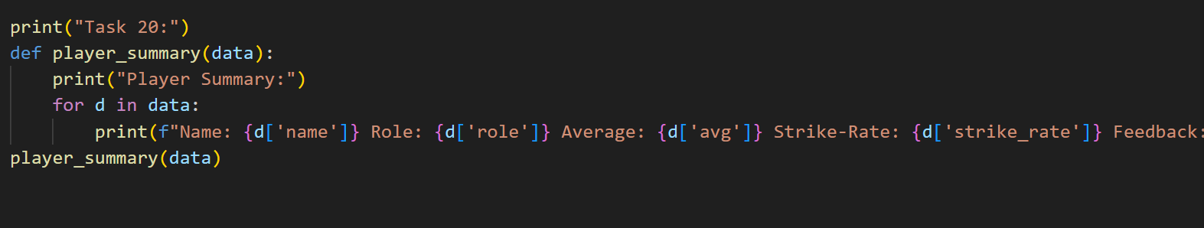

The final task was generating a clean, user-friendly output. I looped through the data and used f-strings to create a concise Summary Card line for each player, displaying their name, role, and all key performance metrics in one easily digestible report format.

